**WEB TECHNOLOGY**

Name: **DIGVIJAY SINGH**

Roll No. : 00414807216

Semester: 6th

Group: C-12



Maharaja Agrasen Institute Of Technology, PSP Area,

Sector-22, Rohini, New Delhi-110086

**WEB TECHNOLOGY**

**PAPER CODE** : **ETCS-308**

NAME OF THE STUDENT : DIGVIJAY SINGH

UNIVERSITY ROLL NO : 00414807216

BRANCH : CSE

SECTION/GROUP : C-12

PRACTICAL DETAILS

|  |  |  |  |  |  |
| --- | --- | --- | --- | --- | --- |
| S.NO | EXPERIMENT NAME | DATE OF PERFORMANCE | DATE OF CHECKING | REMARKS | MARKS |
|  |  |  |  |  |  |
|  |  |  |  |  |  |
|  |  |  |  |  |  |
|  |  |  |  |  |  |
|  |  |  |  |  |  |
|  |  |  |  |  |  |
|  |  |  |  |  |  |

**WEEK -1**

Aim: Static web page in html

Program:

<!DOCTYPE html>

<html>

<head>

<meta http-equiv="Content-Type" content="text/html; charset=UTF-8">

<title>Home</title>

<link rel="stylesheet" href="css/indexcss.css">

</head>

<body>

<div id="menu">

<div id="leftmenu">

<ul>

<li><a href="">Home</a></li>

<li><a href="news.asp">Menu</a></li>

<li><a href="contact.asp">Contact</a></li>

<li><a href="about.asp">About</a></li>

</ul>

</div>

<div id="rightmenu">

<a href="">Admin</a>

<a href="">Cart</a>

</div>

</div>

<div id="quote"><p>"There is no sincerer love <br>

than <br>

The love of food"

</p></div>

</body></html>

Screenshot:

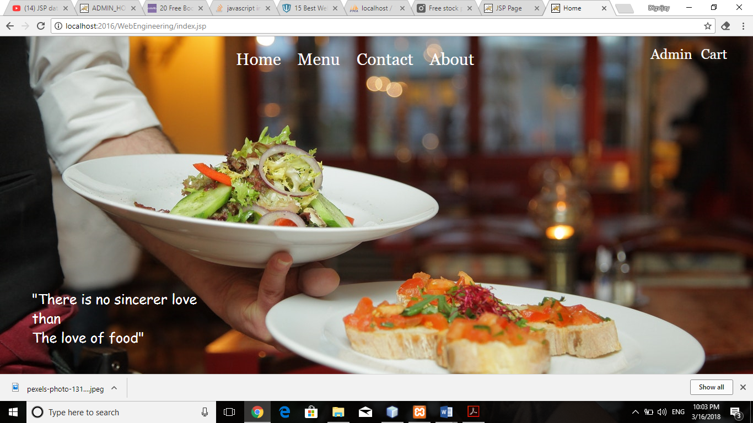

Aim: Installing Xampp on Computer

Xampp for windows 7 version provides an easy to install apache-mysql-php-perl-pear framework. Xampp saves time and effort and provides the software support for web frameworks like drupal, joomla, moodle, or wikimedia on any windows pc.

Steps:

1. Download the installer file for the latest version of XAMPP, and save the file to your computer

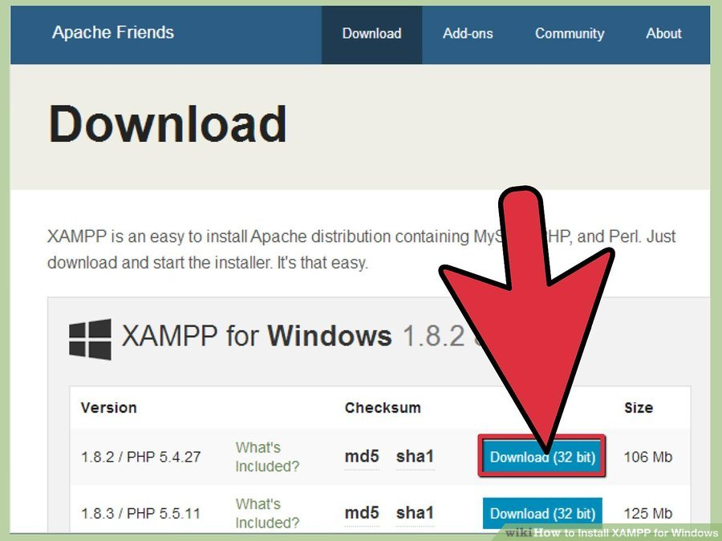

1. Open CD or DVD drive from My Computer. Install the program, and click on "Run
2. Accept the default settings. A command will open and offer an initial installation prompt. Just hit the Enter key, and accept the default settings. You can always change settings, by editing the configuration files later."
3. When your installation is complete, exit the command window by typing x on the command line
4. Start the XAMPP Control Panel

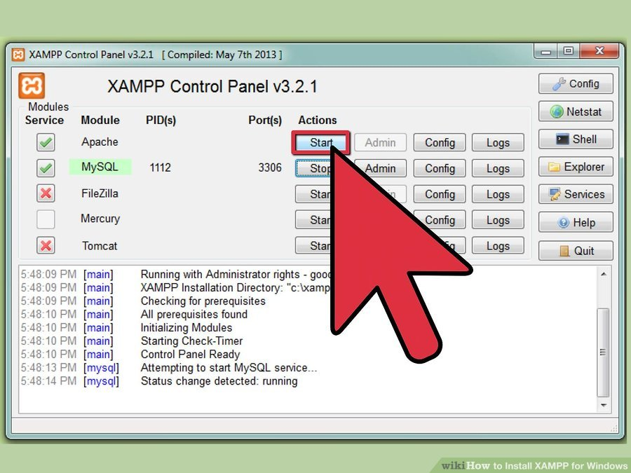

1. Start the Apache and mysql components. You can also start the other components, if you plan to use them
2. Verify the mysql installation, by clicking on the mysql administrative link in the XAMPP Control Panel.
3. If the verification steps are successful, XAMPP should be successfully installed on your PC. Open a browser and enter "localhost" on your address bar. You will be redirected to a page telling you that you've successfully installed xampp on your system

**WEEK -2**

Aim: CSS(Cascading style sheet) for web page

A new feature being added to [HTML](https://www.webopedia.com/TERM/H/HTML.html) that gives both [Web site](https://www.webopedia.com/TERM/W/web_site.html) developers and [users](https://www.webopedia.com/TERM/U/user.html) more control over how [pages](https://www.webopedia.com/TERM/W/web_page.html) are displayed. With CSS, designers and users can create [style sheets](https://www.webopedia.com/TERM/S/style_sheet.html)that define how different elements, such as headers and links, appear. These style sheets can then be applied to any Web page.

The term cascading derives from the fact that multiple style sheets can be applied to the same Web page. CSS was developed by the [W3C](https://www.webopedia.com/TERM/W/W3C.html).

Program:

body

{

background: linear-gradient(rgba(255,255,255,.2), rgba(255,255,255,.2)), url("../images/indexbody.jpeg");

position:absolute;

}

#menu

{

width:100%;

}

#rightmenu

{

float:right;

margin-left:300px;

font-size:25px;

padding-right:10px;

font-family:georgia;

padding: 10px 10px 10px 10px;

}

#leftmenu

{

float:left;

}

ul

{

float:left;

margin-left:350px;

list-style-type: none;

text-decoration:none;

}

li

{

text-decoration:none;

float:left;

color:#000000;

font-size:30px;

font-family:monoscope;

padding-left:20px;

}

a

{

padding-left:10px;

text-decoration:none;

color:white;

opacity:1;}

a:hover

{

font-size:32px;

opacity:0.8;

}

#quote

{

margin:450px 0px 0px 50px;

color:white;

font-family:cursive;

font-size:25px;

}

#foode

{

font-size:50px;

font-family:cursive;

color:orange;

}

Aim: Creating a simple Form in Css and Html

Program:

<%@page contentType="text/html" pageEncoding="UTF-8"%>

<!DOCTYPE html>

<html>

<head>

<meta http-equiv="Content-Type" content="text/html; charset=UTF-8">

<title>Delivery</title>

<link rel="stylesheet" href="css/deliverycss.css">

</head>

<body>

<div id="menu">

<div id="leftmenu">

<ul>

<li><a href="">Home</a></li>

<li><a href="news.asp">Menu</a></li>

<li><a href="contact.asp">Contact</a></li>

<li><a href="about.asp">About</a></li>

</ul>

</div>

<div id="rightmenu">

<a href="">Admin</a>

<a href="">Cart</a>

</div>

</div>

<div id="quote">

Let us know Where to deliver :)

</div>

<div id="container">

<table>

<form action="action_page.php">

<tr>

<td> <label for="fname">First Name</label></td>

<td><input type="text" id="fname" name="firstname" placeholder="Your name.."></td>

</tr>

<tr>

<td> <label for="address">Address</label></td>

<td><input type="text" id="address" name="address" placeholder="Where to deliver.." style="height:30px"></td>

</tr>

<tr>

<td><label for="country">Country</label></td>

<td>

<select id="country" name="country">

<option value="australia">Australia</option>

<option value="canada">Canada</option>

<option value="usa">USA</option>

<option value="INDIA">INDIA</option>

</select></td>

</tr>

<tr>

<td>

<label for="Email">Email</label>

</td>

<td>

<input type="email" id="email" name="email" placeholder="Mail you @..">

</td></tr>

<tr><td>

<label for="Mobile">Mobile</label>

</td>

<td>

<input type="" id="number" name="number" placeholder="9863..">

</td></tr>

<tr><td colspan="2" align="center"><input type="submit" value="Deliver" ></tr></form></table>

</div><body>

</html>

Screenshot:

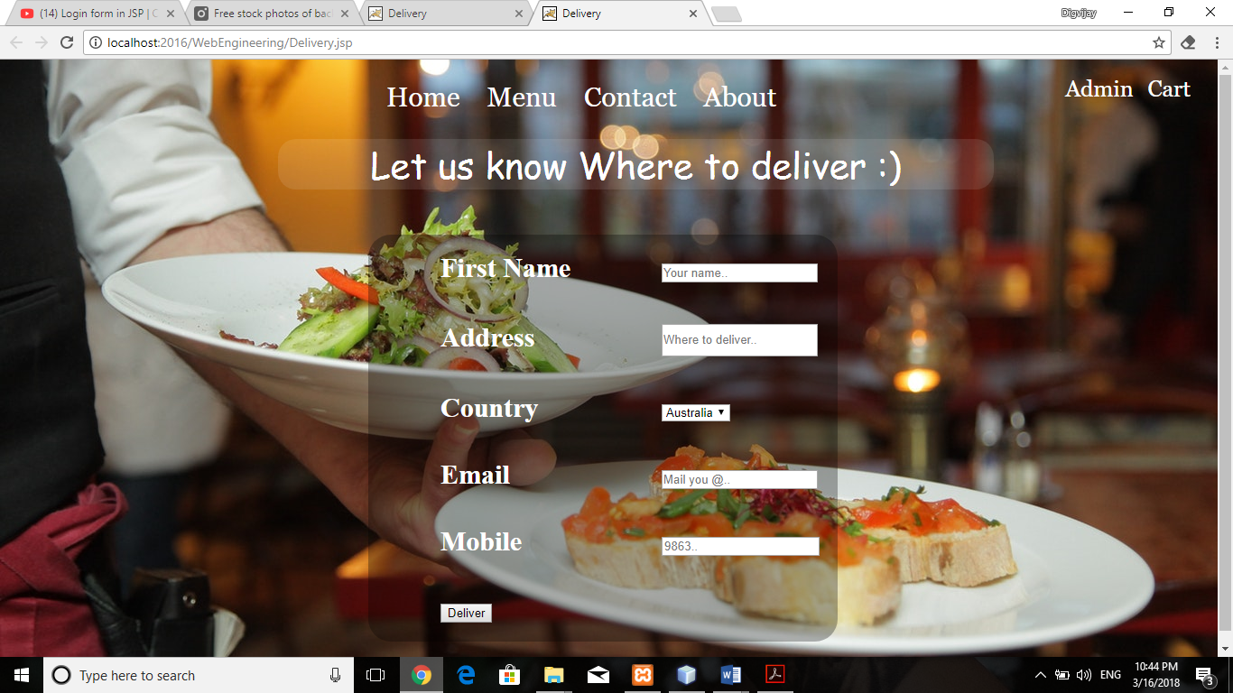

**WEEK -3**

Aim: Jsp(java server pages) and Database(Sql)

**JSP** technology is used to create web application just like Servlet technology. It can be thought of as an extension to servlet because it provides more functionality than servlet such as expression language, jstl etc.

A JSP page consists of HTML tags and JSP tags. The jsp pages are easier to maintain than servlet because we can separate designing and development. It provides some additional features such as Expression Language, Custom Tag etc.

**SIMPLE LOGIN PAGE USING JSP AND SQL CONNECTION**

**Program:**

1. **LOGIN PAGE**

<!DOCTYPE html>

<!--

To change this license header, choose License Headers in Project Properties.

To change this template file, choose Tools | Templates

and open the template in the editor.

-->

<html>

<head>

<title>Admin</title>

<meta charset="UTF-8">

<meta name="viewport" content="width=device-width, initial-scale=1.0">

<link rel="stylesheet" href="css/Adminlogincss.css">

<script type="text/javascript">

function validate()

{

var uname=document.myForm.username.value;

if(uname.length<1)

{

alert("Please enter the Email");

document.myForm.username.focus();

return false;

}

var password=document.myForm.password.value;

if(password.length<1)

{

alert("Please enter the Password");

document.myForm.password.focus();

return false;

}

}

</script>

</head>

<body>

<h1 align="center" style="margin-top: 100px;color: white">ADMIN LOGIN </h1>

<div id="login">

<form name="myForm" method="post" action="login.jsp">

<table>

<tr>

<td>Username : </td>

<td><input type="text" name="username"></td>

</tr>

<tr><td>Password :</td>

<td><input type="password" name="password"></td></tr>

<tr>

<td colspan="2"><button type="submit" class="button" name="action" onClick="return validate();" value="Login" >LOGIN</button>

</td>

</tr>

</table>

</form>

</div>

</body>

</html>

Screenshot:

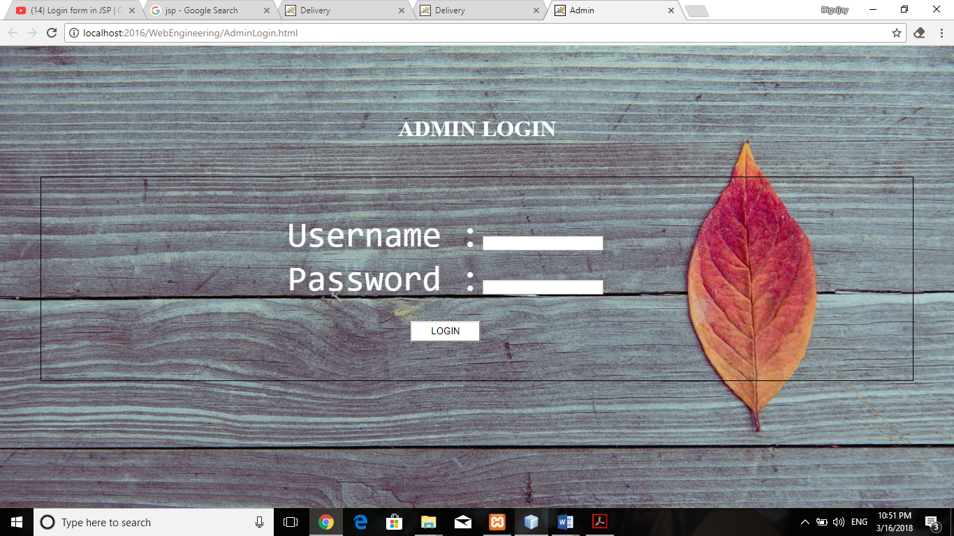

**2).JSP PAGE FOR CONNECTION**

<%@page import="java.sql.*" %>

<%

String action=request.getParameter("action");

if(action.equals("Login"))

{

String User=request.getParameter("username");

String Pwd=request.getParameter("password");

try

{

Class.forName("com.mysql.jdbc.Driver");

String url="jdbc:mysql://localhost:3306/admin?zeroDateTimeBehavior=convertToNull";

Connection con = DriverManager.getConnection(url,"root","")

Statement st=con.createStatement();

ResultSet rs =st.executeQuery("select * from admins where Username='"+User+"' and Password='"+Pwd+"'");

if(rs.next())

{

response.sendRedirect("index.jsp");

} else

{

out.println("<script type=\"text/javascript\">");

out.println("alert('Username and password invalid');");

out.println("location='AdminLogin.html';");

out.println("</script>");

}}

catch(Exception e){

out.println(e);

}}

%>

Screenshot:

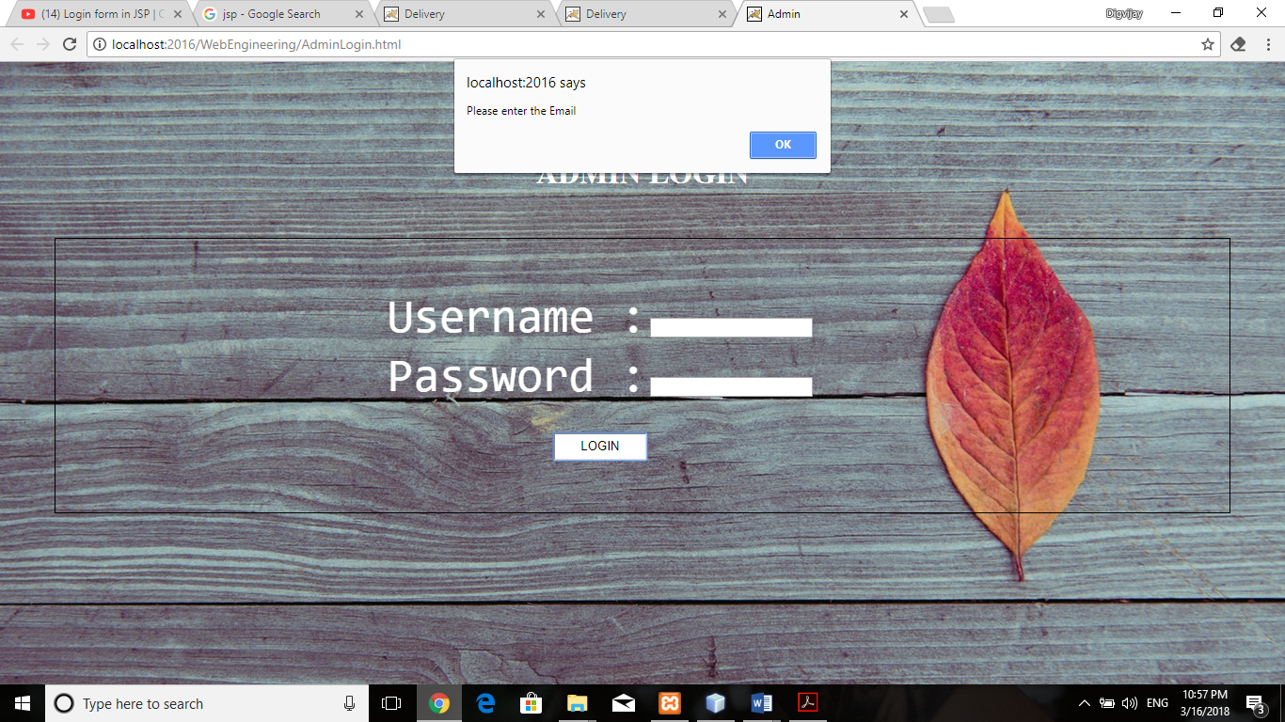

**Please Enter Username & Password**

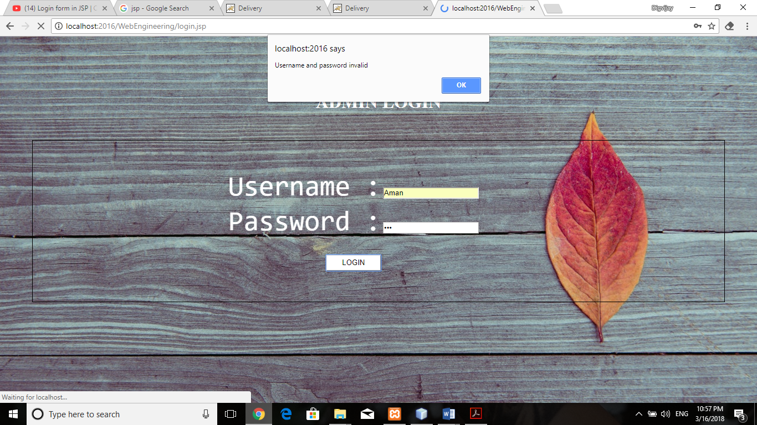

**Invalid Username Or Password**

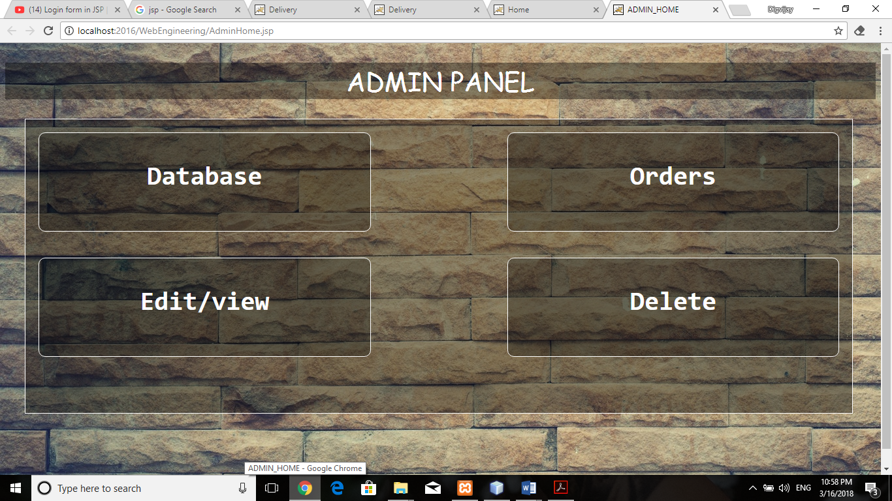

**After Successful Login**

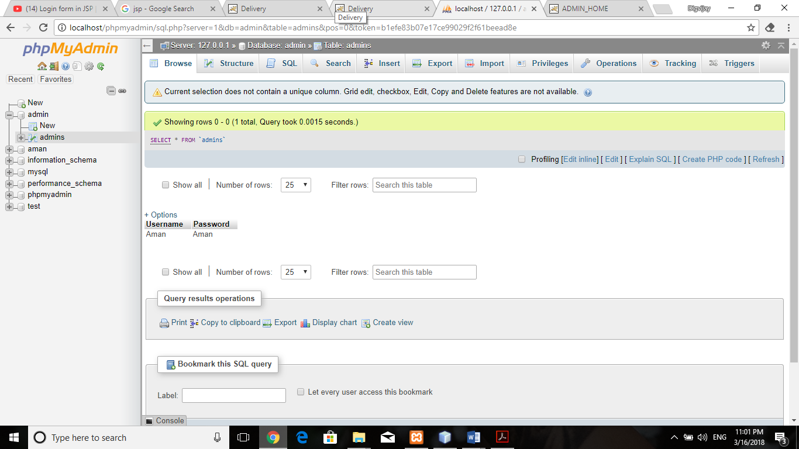

**Mysql DataBase**

**WEEK -4**

Aim: Showing Current Date and Time

**Program:**

<%@ page import = "java.io.*,java.util.*, javax.servlet.*" %>

<html>

<head>

<title>Display Current Date & Time</title>

</head>

<body>

<center>

<h1>

Display Current Date & Time

</h1>

</center>

<%

Date date = new Date();

out.print( "<h2 align = \"center\">" +date.toString()+"</h2>");

%>

</body>

</html>

Screenshot:

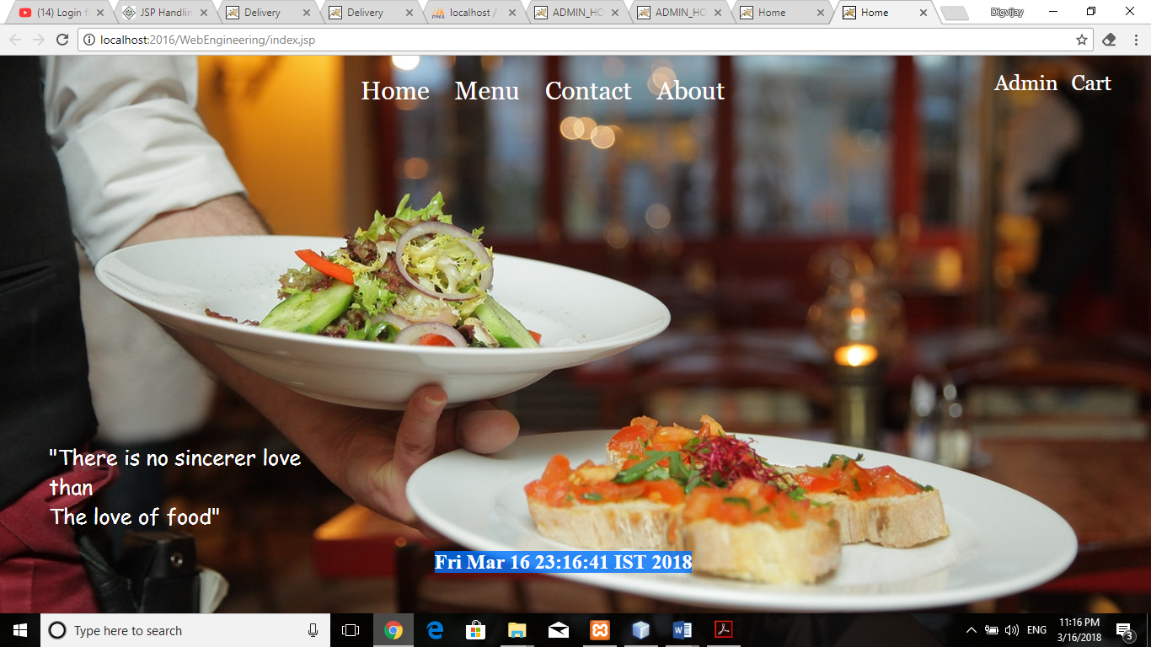

**Aim: Form Validation (Email,Paswword,phone)**

**1)EMAIL VALIDATION**

**Program:**

<script>

function validateemail()

{

var x=document.myform.email.value;

var atposition=x.indexOf("@");

var dotposition=x.lastIndexOf(".");

if(atposition<1 || dotposition<atposition+2 || dotposition+2>=x.length

{

alert("Please enter a valid email address \n atpostion:"+atposition+"\n dotposition:"+dotposition);

   return false; }

If(x.length<1)

{Alert(“Enter Email”);}}

</script>

Screenshot:



**2)Password VALIDATION**

**Program:**

<Script type="text/javascript">

Function matchpass()

{

Var firstpassword=document.f1.password.value;

Var secondpassword=document.f1.password2.value;

If(firstpassword==secondpassword)

{

Return true;

}

Else

{

Alert("password must be same!");

Return false;

}

}

</script>

Screenshot:

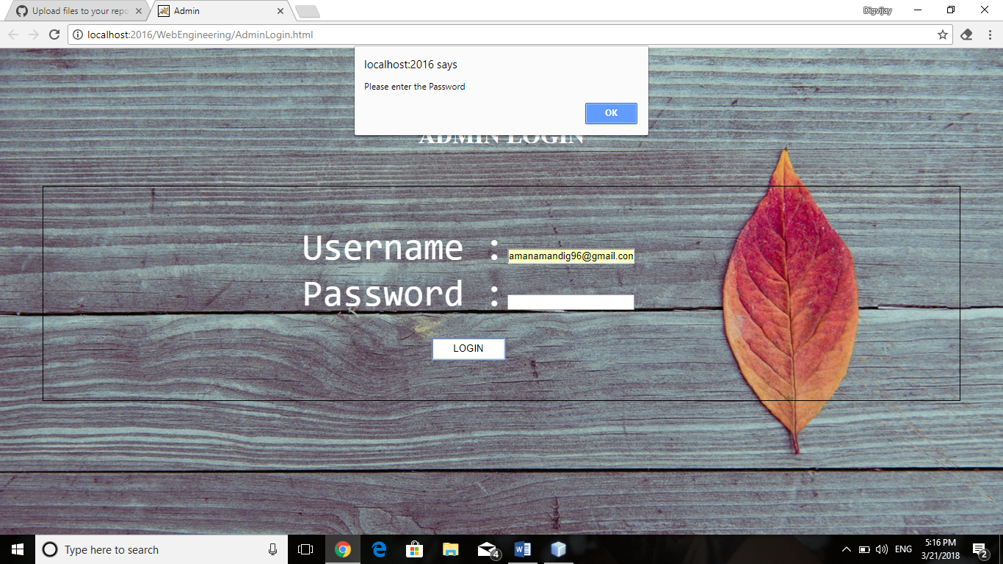

**3)Phone number VALIDATION**

**Program:**

<script>

 function validate()

{

var num=document.myform.num.value;

If (isNaN(num))

{

document.getElementById("numloc").innerHTML="Enter Numeric value only";

  return false;

}

Else

{  return true;  } }

</script>

Screenshot:

